MMSI to $GPGLL

Initialisation File is MMSI_to_GLL.ini
Template File is GPGLL.nmea

There are 3 MMSI’s set up

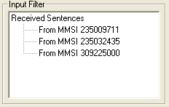

Select the Options
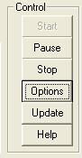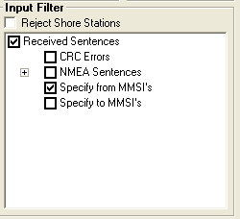
If you Tick Specify from MMSI’s you can add or remove MMSI’s
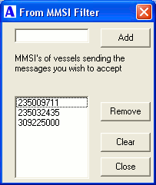
Any AIS message types From the originating MMSI will be passed, all other messages will be rejected.

Ticking GIS filtering prevents output being generated from any AIS messages not containing a Lat and Lon of the originating MMSI
